**Heroes of Pymoli**

Following are three observable trends based on the purchase data of Heroes of Pymoli

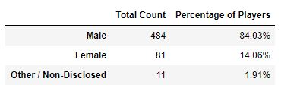

1. Gender Demographics reveals that there are more male player (484) than female player (81).
2. 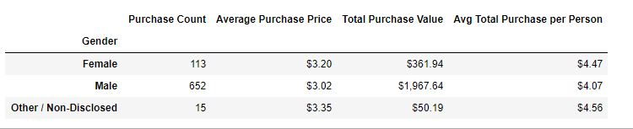Based on Purchasing analysis, count of 652 by male and 113 by female, It is obvious that male purchase more that female. Looking at average total purchase of $4.07 by male and $4,47 by female it can be concluded that female purchase expensive optional items that male.

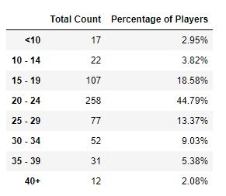

1. Based on Age Demographics, the players who belong to the range of age from 20 to 24 purchase more optional item with total of 258 and purchasing 44.79 % of total Item.